19. Plant Biology II: Transport *(RHM: Chapter 34)*

______________________________________________________________________________

I. Water and Mineral Uptake *(813-819)*

A. Introduction

B. Accumulation of Mineral Ions

1. Inadequacy of diffusion

2. Active transport

C. Entry of Water and Minerals into Xylem

1. Review of root anatomy

2. The symplast pathway

3. The apoplast pathway

4. Transfer to xylem cells

II. Transport in Xylem *(819-825)*

A. Introduction

B. Water Potential

1. Definition

2. Effect of solutes

3. Effect of pressure

4. Application to plant biology

C. Transpiration‑Cohesion‑Adhesion Theory

1. Transpirational pull

2. Cohesion and adhesion of water

3. Tension within xylem

4. Summary of action

D. Control of Transpiration

1. Photosynthesis and transpiration

2. Control of Stomata

IV. Transport in Phloem *(826-829)*

A. Introduction

B. Source to Sink Transport

1. Definitions

2. Variability of flow

C. Phloem Loading and Unloading

D. The Pressure Flow Hypothesis

1. Active transport and water potential

2. Hydrostatic pressure

3. Flow of phloem sap

19-1

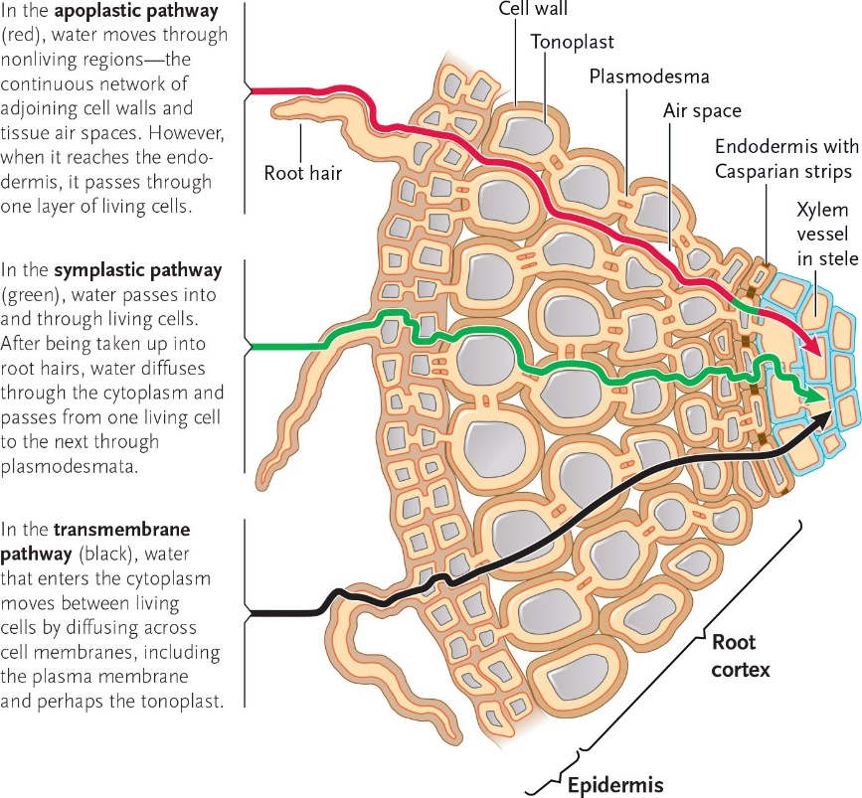 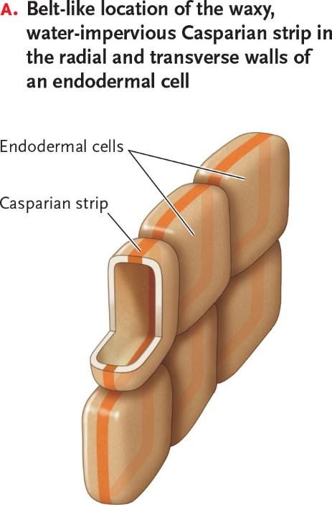

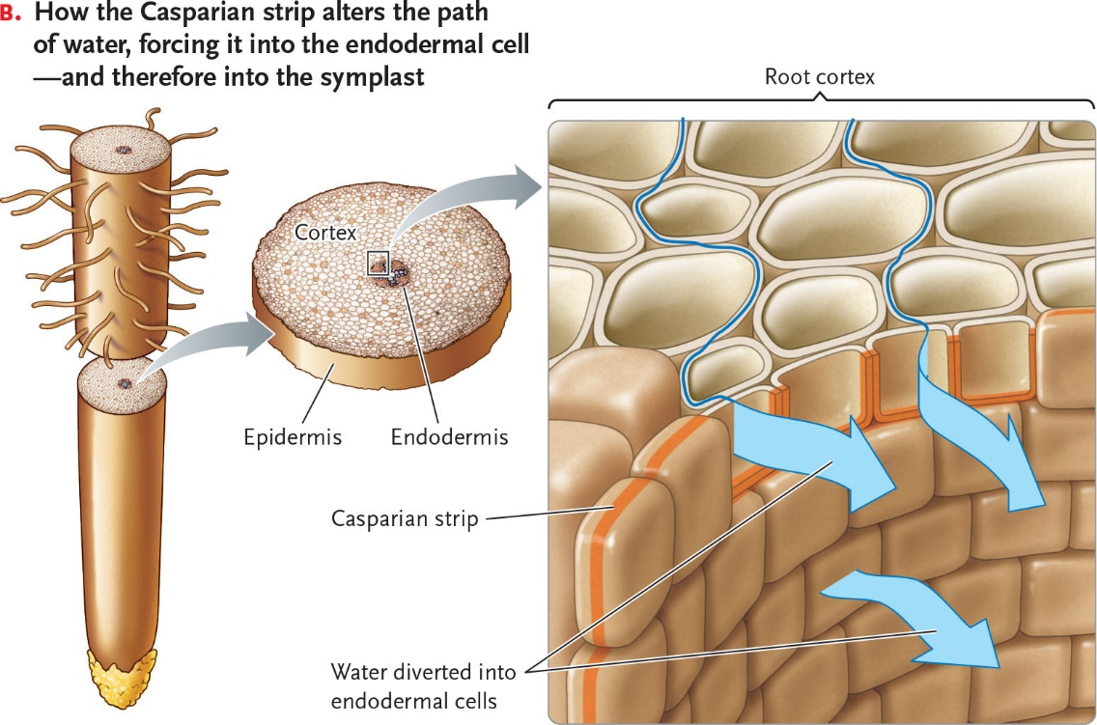

19-2

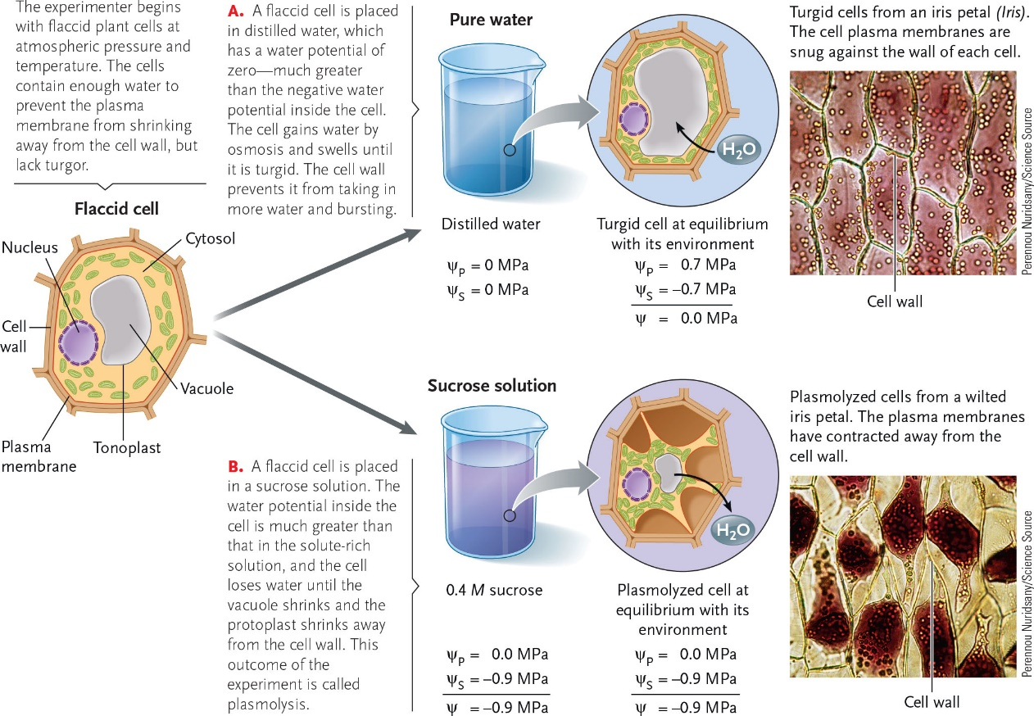

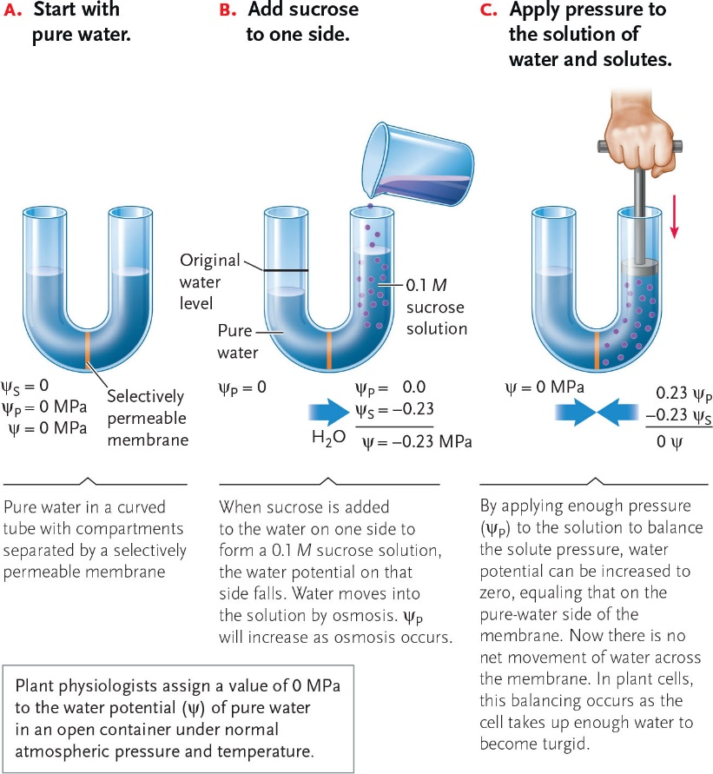

19-3

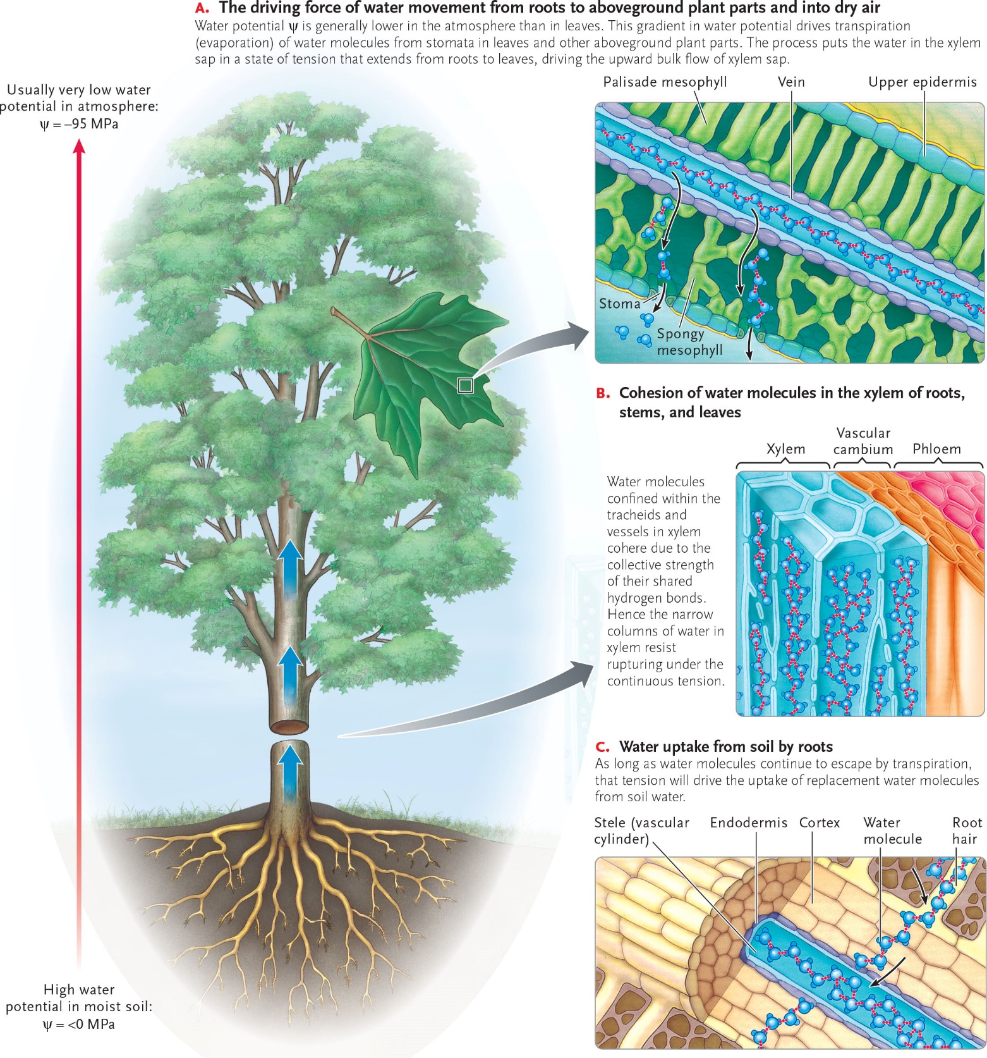

19-4

